<<COURT_NAME>>

|  |  |
| --- | --- |
| <<PROVIDER_SUITNAME>>,  a/a/o <<INJUREDPARTY_NAME>>      Plaintiff,  vs.  <<INSURANCECOMPANY_SUITNAME>>  Defendant. | Case No. |

**SITUS DESIGNATION FORM**

Pursuant to Administrative Directive 2012-04, I hereby certify the situs of this action to be:

( ) (a) Courthouse – Crestview Situs (“North End”) if:

1. The cause of action accrued North of the situs line at Range Road 215 West and Range Road 213 East, as depicted on the attached map, said area to be designated as “North End,” or
2. The cause of action did not accrue in Okaloosa County, but at the time the action is filed, all defendants/respondents reside in the North End.

( ) (b) Okaloosa County Courthouse Annex Extension – Fort Walton Beach Situs (“South (“South End”) if:

1. The cause of action accrued South of the situs line at Range Road 215 West and Range Road 213 East, as depicted on the attached map, said area to be designated as “South End,” or
2. The cause of action did not accrue in Okaloosa County, but at the time the action is filed, all defendants/respondents reside in the South End.

( ) (c) Either Courthouse (Crestview) or Okaloosa County Courthouse Annex Extension (Fort Walton Beach) if:

1. The cause of action did not accrue in Okaloosa County, and no defendant/respondent resides in Okaloosa County; or
2. The cause of action did not accrue in Okaloosa County and the defendants/ Respondents reside in both the North End and the South End of Okaloosa County.

If Plaintiff/Petitioner not If Plaintiff/Petitioner represented

represented by attorney: represented by attorney:

_ Robert Gonzalez Esq. _

Plaintiff/Petitioner’s Signature Attorney’s Signature

_ /s/ Robert F. Gonzalez _

(Type or print name) (Type or print Attorney’s name)

(305) 906-4262

Telephone Number Telephone Number

Alabama

E

N

OKALOOSA COUNTY ADMINISTRATIVE SITUS LINE

BLAACKWAATTER RIIVVEER STTATEE FOREESST

ND

U

Y

L

R

BILL

HWY 189

N

HWY 2

LLAAUURREELL HHILILLL

D

N

Z

E

W E

E

B

HWY

85 N

R

E

R

*OKALOOSA COUNTY ADMINISTRATIVE SITUS LINE*

BLACKWATER RIVER STATE FOREST CINCO BAYOU

CITY OF CRESTVIEW CITY OF DESTIN EGLIN AFB

CITY OF FORT WALTON BEACH HURLBURT FIELD

CITY OF LAUREL HILL CITY OF MARY ESTHER CITY OF NICEVILLE CITY OF SHALIMAR UNINCORPORATED CITY OF VALPARAISO

ETHE

D

G

R

I

E

HWY 4 W

A

N C

HWY 393

B

Baker

4

A

TY

D

RD

BLVD

5 N

N

8

H

W

Y

HWY C

R AIRPORT RD

Milligan

4

GALLIVER C

T

O

M

JA

CRESTVIIEW

L

VD E

L

JAMES LEE B

D

Y

W

H

A

N BLVD

N FERD

O

O

ES LEE

LD

B

L

VD W

Holt

D

R

NTI

O

CH

LOG LA

K

E RD

S FERD

O

HWY 90 E

HWY 90 W

*Range Road 215 Range Road 213*

**OKALOOSA COUNTY ADMINISTRATIVE SITUS LINE**

HW

Y

85 N

HWY 285

EGLIIN AFB

Santa Rosa County

Walton County

SR 29

3

N

123

D

W

NIICEVIILLE

JOHN SIMS PK

G

E

S

R

B

CO

E

L

L

PARTIN

LV

R

D

VVAALLPPAARRAAISISOO

N

5

HWY 8

RAN

HWY 20 E

NE

R

S TU

EGLIN PKWY N

R

E

BLVD

MAP PROJECTION:

W

Y

E

Lambert Conformal Conic Projection Stateplane: Florida North (0903) NAD 1983(90), NAVD 1988.

RD

E

G

PUBLIC RECORD:

This map was created by Okaloosa County GIS and is in the public domain pursuant

to Chapter 119, Florida Statutes.

DISCLAIMER:

Okaloosa County hereby expressly disclaims any liability for errors or omissions in

these maps, indexes or legends.

P

HURLBURT FIIELD

O

O

S

A

EGL

O

K

A

L

I

SHALIIMAR

CCININCCOO BBAAYYOOUU FFOORRTTWWAALLTTOONNBBEEAACCHH

MMAARRYYEESSTTHHEERR

C

M

ID B

Y

*OKALOOSA COUNTY, FLORIDA*

I

N

KW

Y

N

LEWI

L DESTIIN

W HWY 98

MIRACLE STRI

TA ROSA B

N

SA

Y BRIDGE RD

A

V

D

D

MERAL

P

HARBOR BLVD

PKWY

E

Map Produced By: Okaloosa County GIS January 2018

U

PKWY

O

T

COAST

N

Map: Not to Scale

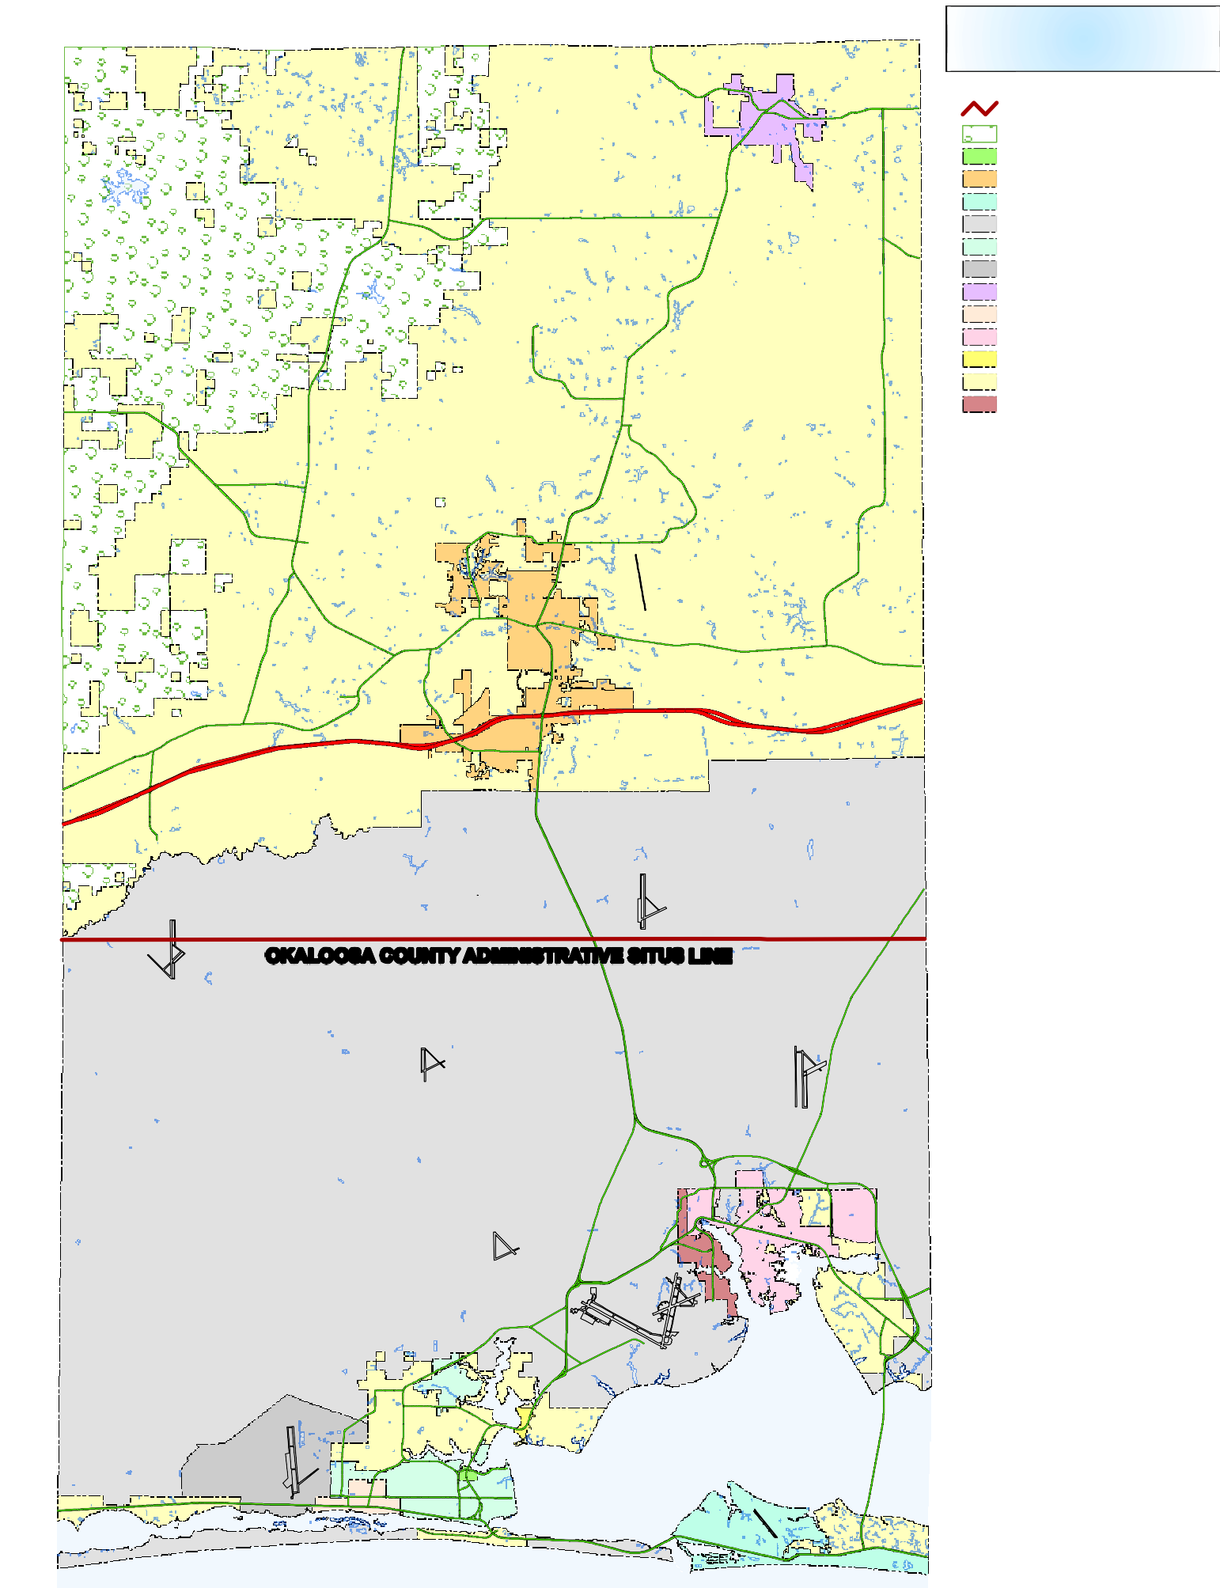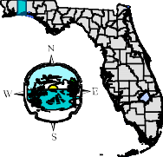

Map: \\gisvm100\gisprojects\MapDocs\Admin\Projects\Judicial\JudicialLine8.5x11.mxd PDF:\\gisvm100\gisprojects\PDFDocs\Admin\JudicialLine8.5x11.pdf, Scale: NTS, OCJASL Revised: 8/2009